LAI KA MAN 09649980G
QING PEI EDWARD 11500811G
ZHANG YULAN 11516753G
TO WAI LUN FERRY 09602469G

Scenario
Methodology
Task Design
Pre-test evaluations
Questionnaires Design
Observations
Questionnaires
Interview Results
Office Web Apps (Tester 5-8)
Login:
Create a New Document
Formatting
Heading Style
Font, Size and Highlight
Formatting Functions
Insert Picture
Sharing
Google Doc (Tester 2 – 4 )
Interpretation: System strengths and weaknesses
System Strengths
System Weaknesses
Suggested Improvements
Layout design
Features Amendment
File Management
Comparative Study
Conclusions
Figures
Appendix 1: Pre-test Questionnaire#
Appendix 2: Post-test Questionnaire#
Appendix 3: Task Description

Scenario
This is an system usability evaluation report for the vice-president of Microsoft on a browser based online collaborative office software named Microsoft Word Web App. The report was created by the employee of ABC usability study company, which contains evaluators for setting up the evaluation experiments and testers for testing the product. This report describe the findings, observations, recommendations of the evaluation results obtained by the experiment conducted by our evaluators and testers. A similar but different product on the market named Google Docs has chosen as the potential competitor to test against the Microsoft Word Web App for usability study.

Methodology
This section will describe the experiment we had conducted for the usability study. The experiment requires our eight testers divided into two groups, one group will test on the Microsoft Word Web App and the other group will test on the Google Doc for the same tasks. The testers participated in the experiment did not use both products before. In addition, before and after the experiment, testers have to fill-in questionnaires for analytical purpose.
Since our experiment objective is usability study on the product. The tasks are designed carefully such that we are not testing the features of the product nor the ability of the testers. As Microsoft Word Web App and Google Doc are browser based online collaborative word processing software, we had designed two tasks in our experiment. Task one focus on usual word processing while task two focus on collaborative editing.
The tasks for our experiment has several modifications during experiment design phrase. This is because we have to ensure each step in our task is available on two different experiment subjects in order to improve our analysis accuracy. Features which only exist on either one experiment subject are eliminated. Please refer to section 7: Comparative Study for more information on the differences of the experiment subjects.
Each tester are paired with one of our two evaluators during the experiment. Tester will be asked by the evaluator to perform the tasks we designed step by step. However, our evaluators will not provide any instructions or hints to the testers for completing each step. Each tester has to figure out how to and complete the requested steps by their own. In addition, testers are also required to speak out what they are doing or thinking during the experiment process. Whenever the testers seems getting stuck on a particular task or forget to speak their mind, our evaluators will ask the testers what they are thinking. Testers participated in the experiment are allowed to skip certain task or step if they are not able to complete it in a predefined time limit.
The experiment environment we set are listed below. For detailed task description, please refer to Appendix 3.

Task Design
To evaluate the target system, we intend to observe users’ performance on a set of selected tasks. In our discussion, we have the following criteria for selecting tasks:
- Tasks should be based on frequently used features in word processors
- Special features of online systems compared to offline ones
- Never ask the user to do time consuming tasks
After brainstorming for what users normally do with a word processor, we narrowed down the choices to a list of functions:
- Format the text. Font size, alignment, line space, etc.
- Insert objects, either images or videos, or smart charts.
- Organize the document. Things like adding a table of contents, a bibliography part, etc.
- Grammar checking & word count.
- Set a background color.
- Open an existing file > editing > save.
- Add header and footer; Add a footnote.
- Search usage information (e.g. column setting) from documentation.
During the alpha test period, Ferry and Edward tried all these tasks in Office Word App and Google Docs and found some missing features in the systems. The missing features are then excluded from our task design.
Among all the tasks listed above, we regard 1, 2 and 6 as the most fundamental functions a word processor should provide. In addition, sharing or collaboration functionality is one of the major reasons people switch to online systems. So sharing a document is also included in our task list.
Then our task list become to be a create-edit-share-edit process. Elaine tried the task list again and found that time consumption may exceed 15 minutes for a novice user. Duplicate text formatting were removed from our task list so that the user only needs to format the text once through out the evaluation.
The final version of task description can be found in Appendix 3. For each group of tasks, we defined the prerequisites. We regard a task is finished when the user reply that the document looks like our reference output.

Pre-test evaluations
Office Web Apps is a relatively new comer in its field while Google Docs has long been the top player. With experience with both systems for more than 4 years, Edward has always chosen Google Docs as the editor while Sky Drive works better as an online storage space.
In the fight of storage space, Google Docs provides 1GB free space, much less than Sky Drive’s 25GB. If we do not want to pay for more than 1GB, we have to convert everything to Google’s format, which does not count in that size limit. In terms of single file limit, Google Docs size limit for its own format is counted in characters/cells, roughly 10~20MB. Files in other formats can be up to 10GB, which is way larger than the free space offered. Sky Drive allow single files up to 50MB.
The Office Web App interface is basically a copy of Office 2007’s ribbon style. The icons are smaller than Google Docs’s new theme. This may not be a problem for mouse users. But when the user is working with a trackpad or on a tablet, bigger buttons are a plus.
And a minor difference is that Office Web App is something hidden inside Sky Drive. There is no link to this service in the navigation bar on top of the page. A link named “Documents” exists in Google’s navigation bar. This may imply that Office Web App is not a killer app Microsoft is trying to introduce to users, at least for now when its functionality is still rudimentary.
Anyway, if we are comparing the basic word formatting features, Office Word App should not be inferior since Microsoft is so experienced with its Office suite.

Questionnaires Design
In pre-test questionnaire (Appendix 1. Pre-test questionnaire), we tried to collect data of users’ age and education background; their preference of using operating system and word processing software; their frequencies and purpose of using word processing software; their experience on using online word processor and file sharing. We are trying to understand the users’ background, their practice on using operating system and word processor, also their experience on file sharing through the questionnaire. Users’ background and experience will affect their test performance.
In post-test questionnaire (Appendix 2. Post-test questionnaire), we tried to collect data of users’ grading, feelings and comments after they used the system (which included system layout, features, and icons). The results will reflect their acceptable level of the system including how easy to use; how user-friendly; how useful on features. Those valuable comments can help on the system improvement and development in the future.

Observations

Questionnaires
From all responses of pre-test and post-test questionnaires, all users has experience in MS word (Fig. 3.1.2) and use it everyday (Fig. 3.1.1) in format editing, but they still found the Office Web apps are not really easy to use (Fig. 3.1.3) and easy to find the features. (Fig. 3.1.4) Meanwhile, there are 75% users to express that they will not use Office Web apps again(Fig. 3.1.5) nor introduce to their friends. (Fig. 3.1.6) Comparing with the competitor Google Doc, there are 43% didn’t use this system but they all agree that is easy to use and user-friendly. Meanwhile, 100% users willing to introduce to their friends (Fig. 3.1.9) and 75% express that they will use again. (Fig. 3.1.10) On the other hand, 100% users has file-sharing experiences by using email; 71% users by using network drive and 43% by cloud storage. (Fig. 3.1.11)
From users responses, we found that the Office Word Apps is not totally relevant to offline Word software. For example, there is no icon for formatting or copying and some operating techniques cannot apply to system. Meanwhile, users felt surprise that even through Office Word Apps and Hotmail are related to Microsoft, the notification email of file sharing which sent from the system will classify as junk or spam mail.
It proves why users felt the system is not easy to use or find the expected features of their offline counterpart. It is not user-friendly and the users’ prior experience of offline word processing is not fully mapped, transfer, or apply to the Microsoft Word Web App.

Interview Results

Office Web Apps (Tester 5-8)

Login:
As all the testers are university students who use computer in their everyday life, it is expected that they can all login a system without hesitate if the system is designed properly. However, Tester 7 asked “how to sign in” after having the first scan of the login page, scrolled the webpage down and up again, and took about twenty-five seconds to figure out where to click for login. Comparing the below two login pages of different product from the same company, the size and location of the Sign In button of Hotmail page will be easier for users to perform the login task and eliminate possible mistakes and Office Web Apps page needs some improvement.

After user signs in the system, the webpage is refreshed but remains the same content, as Tester 5 commented, the system is better to show the login person name at the right up corner instead of keeping the “Sign In” words.

Create a New Document
It seems that most of the testers cannot create a new document without any hesitation although they have been told that “just try whatever you like and don’t worry about any mistakes”. Different from the sign in button, the button for start a new document is large enough; however, users still cannot identify the button quickly, e.g. Tester 5 takes about half a minute to decide whether click on the “Get started free” button, Tester 6 clicked some content of “Help with web apps” at the bottom before clicking the right button. It is interesting to find that Tester 7 performed another way to create the new document: she clicked on a word document template at the button of the front page and tried to edit this template, an error occurred because the template is not editable, and the webpage is directed back to the page showing all the folder of SkyDrive, she clicked some click-able items like “My Document”, “Document” at the left hand side menu and finally found the Word icon to create a new word document. The whole process took about 90 minute while the quickest way only takes one second if tester knows where to click.

Formatting

Heading Style
The function of setting Heading Style in Office Web Apps is considered as good since most of the testers can perform this step without much hesitate. Tester 7 did not understand that “Heading 2” was a text style, so that she failed to perform the step of changing the text style of some lines to “Heading 2” or “Heading 3”. In the task design, it is assumed that users know how to set Headings, however it is not always true. Thus, the performance of this step of Tester 7 will not be considered into evaluation of the system.

Font, Size and Highlight
The using of these functions is performed by users in a reasonable time slot. However, it required some explanation on what does it mean by Highlight. This may indicate that the Highlight function is not commonly used among office users.

Formatting Functions
Some of functions in Office but not Office Web Apps are commonly used and expected from user. Tester 5 would like to use the Brush function to copy the style during the test and Tester 7 wanted the line spacing function. But they cannot find those popular used function buttons because Microsoft does not include then into Office Web Apps. The gap between user expectation and the actual service provided may cause user dissatisfaction.

Insert Picture
This function may satisfy most of the users but some would expect the Office Web Apps to support copy and paste of picture as in Office. Three of our users used the menu item to insert the picture but Tester 6 would like to paste a picture into the file and tried twice: firstly she used keyboard to paste the picture and later she would like to find the Paste function button but that function is not provided in Office Web Apps.

Sharing
As it is a very important function to distinct an online word processing system with an offline one, this function should be put at the first layer and requires minimum clicks. Two of our testers encountered difficulties in finding the sharing function. Tester 6 spent about 150 seconds to figure out where is the button for sharing and Tester 8 spent even spent more time because she left the file editing window and tried to create a new folder which will be shared to another user and planned to move the file just created to the shared folder, but she stopped creating the folder after speaking out the idea and enter the page listing out all the documents and found the button to share the document. The fastest way to sharing setting page only requires 2 clicks however because the user did not find it at the first layer and left the original editing page, it may take more than 7 clicks. It will be much better if the sharing button can be placed in the editing page and can be identified by users. This will eliminate much more mistakes than putting the button under “File”.
The most serious problem found in this system is also related to the sharing function: user can only receive notification email in spam mailbox after others share a file with you. Only Tester 8 was able to find the notification by herself and got access to the shared file. Tester 5 expected to be able to view the file in the folder even if others share a file with her without notification and expect to receive an email in mailbox if others share a file with notification; Tester 6 and Tester 7 expect to access the shared file by clicking the left menu like “My Files”; although Tester 8 successfully accessed the shared file, the first places she was looking for were also same as Tester 6 and Tester 7. Based on the expectation of users, Office Web Apps will be more user-friendly if there will be some indication of where to find the newly shared documents.
Problem also occurs when testers attempted to cancel the sharing with others. Tester 7 and Tester 8 thought they could cancel the sharing by setting the file to be only used by “me” without deleting the other account (they have previously share file with). However, the sharing setting is only eligible for the messenger contacts: the file can only be accessed by you among all the contacts in Live Messenger, but other people like the account who shared with should be managed separately. Tester 8 commented that system should explain clearly about the two different sharing setting functions.

Google Doc (Tester 2 – 4 )
We observed that most user will base on their past experience on offline word processing to paste text via right clicking the screen and select paste from the context menu, but Google Doc does not support it (Ref: Tester3 00:09:05 – 00:09:16 and Tester4 00:08:47). Afterwards user try to paste the content by clicking “Edit> Paste” from the menu bar, a dialogue box pop up and prompt user to use certain key combination to paste the text (Tester3 00:07:23 and tester4 00:13:06-22). Meanwhile, users willing to repeat same action but will not search the layout for icon or function to help. (Example: copy format. Ref: Tester2 00:09:41 – 00:10:10) And also, they will ignore the system dialogue box hints and try to find their target from menu one by one. (Tester3 00:10:15 – 00:10:40)

Interpretation: System strengths and weaknesses

This section describes the system strengths and weaknesses in terms of usability which we discovered from our observation.

System Strengths
- Provides huge free storage space. (25GB per account)
- Document sharing without effort
  - If user could manage to access the share feature, document sharing is just a few clicks, and user can a wide variety of contacts, including Live Messager contact without typing.
- Microsoft Word direct support
  - It enables online document editing with Microsoft Word for advance features to provide higher usability.
- Lightweight design
  - Advanced feature are removed to constraint user focus on core word processing task.
- User interface of better affordance
  - Ribbon bar provides brief information of style and format. User can know what each option look like without second guessing.

System Weaknesses
- Misleading layout design
  - Its difficult to find the entry point of the system, for example tester 7 get confused and took twenty five seconds on figure out how to login the system. There are lots of advertisement on the index page, which makes the only entry button not easy to locate.
- Unresponsive/Inappropriate feedback
  - The system does not provide timely feedback, which makes users confused and uncomfortable. For example, when tester 5 logged in the system, the page does refresh. However, the web page still display the same content with the sign-in image, it makes the tester confuse whether he is already logged in or not; Besides, when tester logged out the system, the system caused the browser keep loading a blank page until browser timeout, tester have no ways to figure out what is happening.
- Inconsistent workflow from desktop application
  - The experience from desktop Microsoft Word cannot directly transfer to Microsoft Word Web App. For example, tester 5 and tester 7 attempt to use the brush and line spacing feature to complete the task but they failed as Microsoft Word Web App does not provide this feature.
- Misplaced location of important feature
  - Some essential features are hidden and not easy to find. For example, tester 6 and tester 8 find difficult to figure out how to share a document. The file sharing button hidden under the File menu, which is not obvious to user.
- Wrongly implemented feature
  - Some features is not working as expected. For example, when user shared a file, other users being shared should receive a notification email about this. However, the email system of Microsoft classify the share notification as junk mail thus user will not get notified as expected. Only tester 8 in our experiment able to discover the share notification in her junk mailbox.

Suggested Improvements
According to conceptual models, there are some suggestions to the system.

Layout design
- Provide easier ways to login the system. For example, reposition and enlarge the existing sign in button to make it more obvious to user.
- Eliminate confusion. For example when user logged in the system, it should show the login status and the identity of user, and hide the sign in button to avoid confusion. In addition, when user clicks sign out button, it should transfer the user back to index page instead of keep loading a blank page, which is annoying and confusing.
- Provide easier ways to share document. An obvious share button on the screen can ease the sharing process by just one click to fulfill user needs.

Features Amendment
- Make share notification work as it intended. User should have the option for whether send out notification of file sharing and the notification email should not incorrectly classify as junk mail.
- Make the system work more seamlessly with it offline counterpart. The system should provide add-on features which work the same as offline application to avoid on and offline application conversion.

File Management
- It should increase the flexibility of file management. E.g. like the competitor Google Doc, provides indexing instead of copying files into different folders physically.

Comparative Study
As stated in section 2: Methodology, the tasks we designed for our experiment had encountered restrictions due to the products capability differences. Below are the differences which affected our task design:
Feature | Microsoft Word Web App | Google Doc
Edit online document on desktop application | Can edit online document directly in Microsoft Word | Not supported
Document format support | Support Microsoft Word format (.doc, .docx) only | Support multiple document formats
Create table of contents | Not supported | Supported
Edit header | Not supported | Supported
Edit footer | Not supported | Supported
Word count | Not supported | Supported
Translate document | Not supported | Supported
Document sharing | Folder level sharing | Supported
Real time collaborative editing | Not supported | Supported
Comment editing | Not supported | Supported
Document versioning | Supported | Not supported
Line spacing adjustment | Not supported | Supported
Copy/Paste text via context menu | Supported | Not supported

Despite of features differences, there are features that both system contains but their action-interpretation model is widely differed, which also affects our task design:
Feature | Microsoft Word Web App | Google Doc
File saving | Save button exists, user have to save the document manally | Automatically saved when changes made. Save button does not exists, display saving/saved status instead
Default file name | Require a file name before user can edit a new file | File created with default file name, user can change it afterwards
Style and format presenation | All listed in the ribbon bar with preview | Hidden in combo box without preview
File sharing feature location | Hidden under File menu | Obvious button shown on upper right corner of the screen
Images insertion | Select insert image from ribbon bar | Allow drag and drop from desktop in addition to menu
Retain Microsoft Word document layout | Style, format and layout can retained exactly as in Microsoft Word | Content maybe mispositioned and style may lost

The differences are large as both product has different target audience. The Microsoft Word Web App aims to provide a free lightweight version of Microsoft Word for novice user which had previous experience in Microsoft Office products. While Google Doc is a product for user that are already familiar in using computers to edit documents collaboratively.

For example, as stated in section 3 Observations, some testers attempted to right-click the screen to call out the context menu for pasting text. This feature only exist in Microsoft Word Web App but not Google Doc because the later assumed their user are familiar with using keyboard shortcuts for copying or pasting text. On the other hand, novice or casual users seldom use advanced features like line spacing, header/footer editing, and table of contents. This is a kind of constraints which limit the choice of the users thus they can focus on their work without hesitation on other possibilities. This also applies to the single document format support and no collaborative editing support in Microsoft Word Web App. Microsoft has designed such that if the user is familiar with word processing, he can reach the advanced features by editing the document via the Microsoft Word offline version.
This maybe the reason explaining why advanced computer users prefer Google Doc more and complain about missing features in Microsoft Word Web App. This is because the design model of Microsoft Word Web App does not match the conceptual model of the advanced users. Likewise, the ribbon bar which exists in recent versions of Microsoft Word and Microsoft Word Web App seems designed for non-expert word processing users. The verbose information and preview on different style and format it provides had lowered the threshold and learning curve of word processing with better mapping and affordance. However, it seems Google Doc without taking these into consideration.

Conclusions
This report has described an usability study experiment conducted on Microsoft Word Web App with a potential competitor Google Doc. Experiment results are obtained from think-aloud test for pre-designed tasks and questionnaires filled before and after the test. The observation section described the feedback from the testers and attempted to interpret them. With the information and analysis performed in this report, we conclude that the usability of Microsoft Word Web App is not satisfactory and requires improvement in several areas. Even most daily Microsoft Word users find it is hard to use and not user friendly. On the other hand, most testers think the potential competitor is more intuitive. We recommend Microsoft to rethink about the flow and layout design of Microsoft Word Web App to be more user and task centric, and consider apply human computer interaction practices.

Figures
Fig. 3.1.1 How often to use word processor?
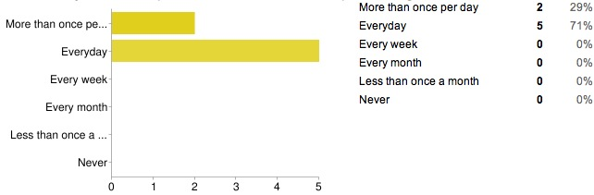
Fig. 3.1.2 Which of the word processor do you often use?
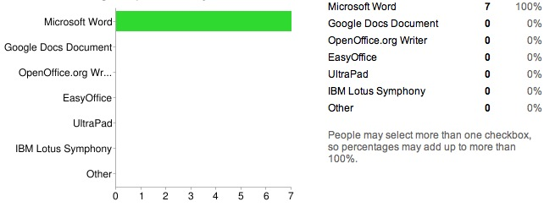
Fig. 3.1.3 Is Office Word Apps easy to use?
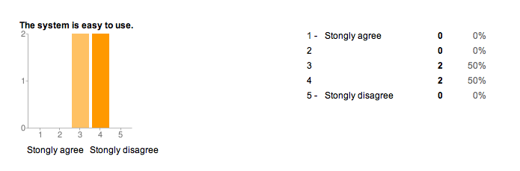
Fig. 3.1.4 Is it easy to find feature in Office Word Apps?
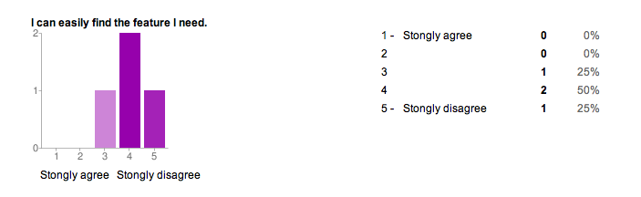
Fig. 3.1.5 Will you use Office Word Apps again?
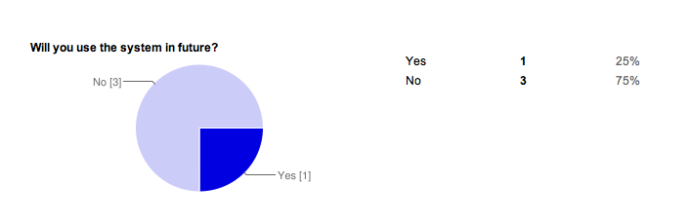
Fig. 3.1.6 Will you recommend Office Word Apps to your friends?
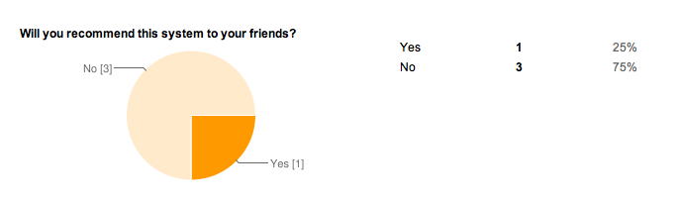
Fig. 3.1.7 Is Google Doc easy to use?
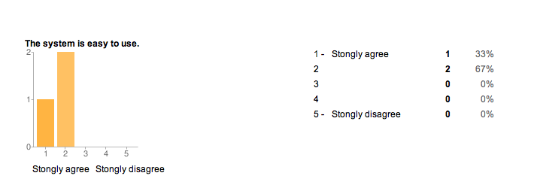
Fig. 3.1.8 Is Google Doc user friendly?
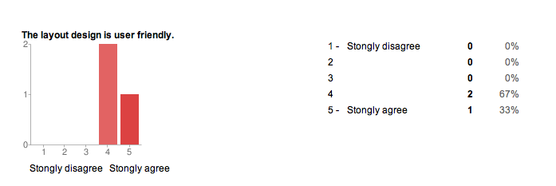
Fig. 3.1.9 Will you use Google Doc again?
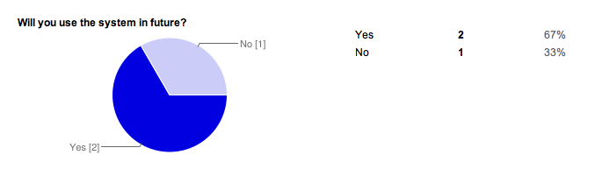
Fig. 3.1.10 Will you recommend Google Doc to your friends?
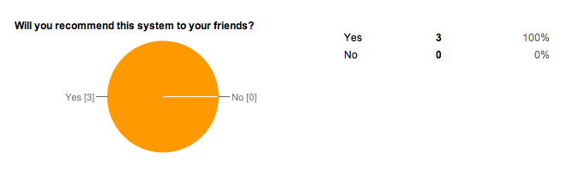
Fig. 3.1.11 Where do you store the share document?
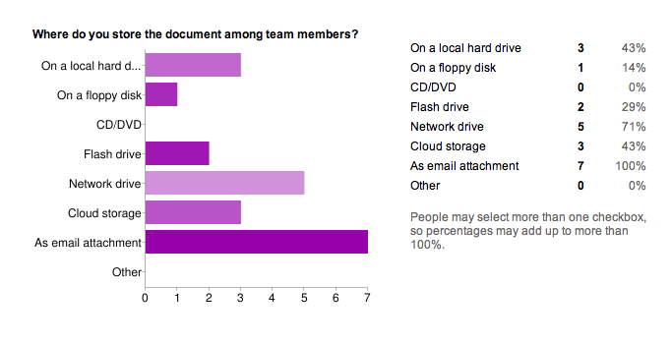

Appendix 1: Pre-test Questionnaire
* Required

How old are you? *
- below 15
- 15 – 20
- 21 – 25
- 26 – 30
- 31 – 35
- 35 – 40
- above 40

What is your education background? *
- Art & Social Sciences
- Business & Finance
- Computer Science
- Law
- Nature Sciences
- Engineering
- Other:

What operating system do you mainly use? *
- Microsoft Windows
- Mac OS X
- Unix/Linux
- Other:

How often do you use a word processor like Microsoft Word or OpenOffice.org Writer? *
- More than once per day
- Everyday
- Every week
- Every month
- Less than once a month
- Never

Which of the following word processor do you often use? *
- Microsoft Word
- Google Docs Document
- OpenOffice.org Writer
- EasyOffice
- UltraPad
- IBM Lotus Symphony
- Other:

What functions do you usually use in word processors? *
- Text formatting
- Tables
- Figures and charts
- Spell checking
- Mail merge
- Equations
- Other:

What do you use a word processor for? *
- Document editing
- Printing
- Webpage editing
- Writing letter
- Other:

Do you have experience with online word processor? *
- Yes
- No

What online word processor have you used before?
- Google Docs
- Office Web Apps
- Other:

How often do you use online word processor?
- Every day
- Every week
- Every month
- Less than once a month

Do you have experience in collaborating on a document with other team members? *
- Yes
- No

Where do you store the document among team members?
- On a local hard drive
- On a floppy disk
- CD/DVD
- Flash drive
- Network drive
- Cloud storage
- As email attachment
- Other:

You are ready to submit the answers.
Thank you very much for your time.

Appendix 2: Post-test Questionnaire
* Required

I have just tested the system: *
- Google Docs
- Office Word App

Which of the following task(s) can be done in appointed time?
- Task 1 (Editing, Formatting, insert image)
- Task 2 (File sharing)

The system is easy to use. *
Strongly agree | 1 | 2 | 3 | 4 | 5 | Strongly disagree

The layout design is user friendly. *
Strongly disagree | 1 | 2 | 3 | 4 | 5 | Strongly agree

The features are useful. *
Strongly agree | 1 | 2 | 3 | 4 | 5 | Strongly disagree

The icons are meaningful and intuitive. *
Strongly disagree | 1 | 2 | 3 | 4 | 5 | Strongly agree

I can easily find the feature I need. *
Strongly agree | 1 | 2 | 3 | 4 | 5 | Strongly disagree

Will you use the system in future? *
- Yes
- No

Will you recommend this system to your friends?
- Yes
- No

Do you have any recommendation for improvement the system? (e.g layout)

Appendix 3: Task Description

Prepared materials:
- source.doc
- prepared.doc
- polyu.gif
Task 1:
Objective: Typical word processing
Time limit: 5 mins
Pre-requisites:
- Browser opened
- Tester already logged in the system and showing the main page of the Microsoft Word Web App or Google Doc
- The materials (source.doc and polyu.gif) for the tasks are placed on the same computer.
- Source.doc is opened in different browser instance.
Steps:
- Create a new file and name it to tester#.doc (e.g tester1.doc)
- Copy text from source.doc to the new created document
- Edit tester#.doc, format the whole line starting with “Assignment 1” with paragraph style to heading2
- Format paragraph style of the line “Step 0: Complete the Scenario”, “Step 1: Role Division”, “Step 2: Select your core set of typical tasks”, “Step 3: Prepare the questionnaires” to heading3
- Select all text and change text color to dark grey
- Change the font of the first paragraph to Gerogia
- Insert polyu.gif to the top of the document
- Save changes

The result document should look like prepared.doc

Task 2:
Objective: Collaborative editing
Time limit: 5 mins
Pre-requisites:
- Task 1 complete
- Logged in with tester account A
- Browser showing system default page
Steps:
- Share tester#.doc to tester account B
- Logout tester account A
- Login with tester account B
- Open tester#.doc
- Highlight the title of first paragraph with yellow color
- Save changes
- Logout tester account B
- Login tester account A
- Remove sharing of tester#.doc from tester account B

The original Google Form is available at http://goo.gl/xbzWw
The original Google Form is available at http://goo.gl/OIVZi

